Java Assignment

1) to find whether a given year is leap year not?

public class Main {  
  
 public static void main(String[] args) {  
 // write your code here  
  
 int year = 1996;  
 boolean leap = false;  
 if (year % 4 == 0) {  
 if (year % 100 == 0) {  
 if (year % 400 == 0)  
 leap = true;  
 else  
 leap = false;  
 }  
 else  
 leap = true;  
 }  
 else  
 leap = false;  
  
 if (leap)  
 System.*out*.println(year + " is a leap year.");  
 else  
 System.*out*.println(year + " is not a leap year.");  
 }  
}  
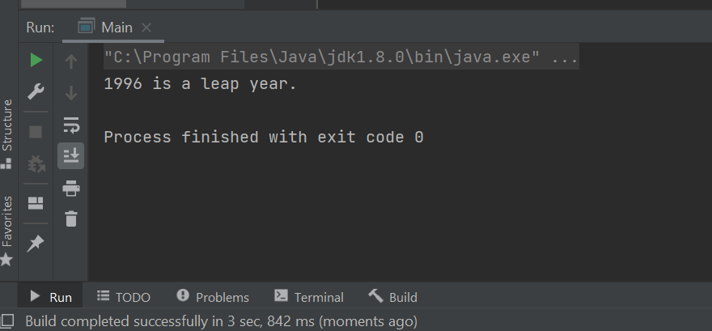

2) to find the amstrong number

public class Main {  
  
 public static void main(String[] args) {

int number = 371, originalNumber, remainder, result = 0;  
  
 originalNumber = number;  
  
 while (originalNumber != 0)  
 {  
 remainder = originalNumber % 10;  
 result += Math.*pow*(remainder, 3);  
 originalNumber /= 10;  
 }  
  
 if(result == number)  
 System.*out*.println(number + " is an Armstrong number.");  
 else  
 System.*out*.println(number + " is not an Armstrong number.");  
 }  
  
}

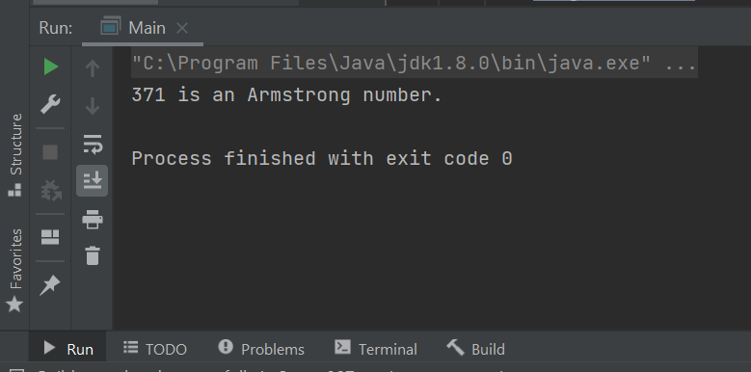

3) to find a perfect number: a number whose factors sum except itself,

equal to the same number

Public class perfect{

static boolean isPerfect(int n)  
 {  
  
 int sum = 1;  
 for (int i = 2; i \* i <= n; i++)  
 {  
 if (n % i==0)  
 {  
 if(i \* i != n)  
 sum = sum + i + n / i;  
 else  
 sum = sum + i;  
 }  
 }  
 if (sum == n && n != 1)  
 return true;  
  
 return false;  
 }  
  
  
 public static void main (String[] args)  
 {  
 System.*out*.println("Below are all perfect " +  
 "numbers till 100");  
 for (int n = 2; n < 100; n++)  
 if (*isPerfect*(n))  
 System.*out*.println( n +  
 " is a perfect number");  
 }  
}  
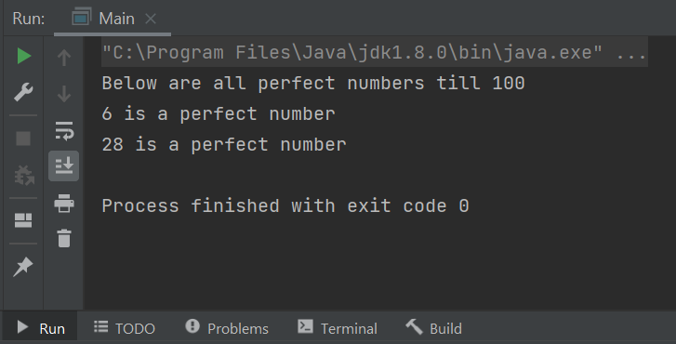

4) to print multiplication table

int num, i, tab;

Scanner scan = new Scanner(System.in);

System.out.print("Enter a Number : ");

num = scan.nextInt();

System.out.print("Table of " + num + " is\n");

for(i=1; i<=10; i++) {

tab = num\*i;

System.out.print(num + " \* " + i + " = " + tab + "\n");

}

